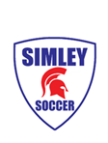
2020 Simley Boys Soccer Warm-Ups
***SAME AS 2019 SEASON***

Order now for 2020 season.

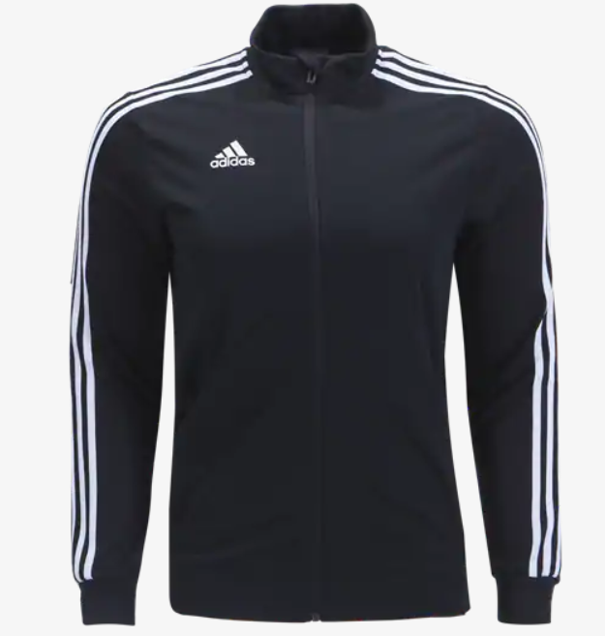 | Adidas Training Jacket  Available sizes: Small, Medium, Large, XL, XXL  Price includes logo on chest and last name on back.  $70.00 | Size: _____  Name on back:  ___________________
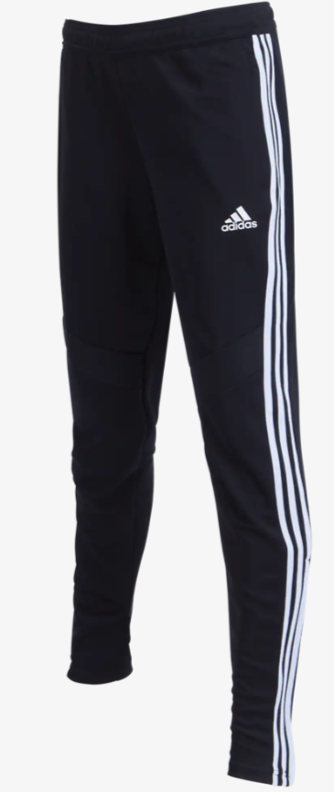 | Adidas Training Pants  Available sizes: Small, Medium, Large, XL  $35.00 | Size: _____

Player Name ____________________________________________________ Grade _____________________

Email __________________________________________________________ Order Total _________________
Ways to order:
- Order online at www.simleysoccer.com (preferred)
- Drop off order form and payment (in envelope) at parent/player meeting Thursday Aug. 13

ALL ORDERS DUE FRIDAY AUGUST 14
Checks payable to PromoAdvantage.

