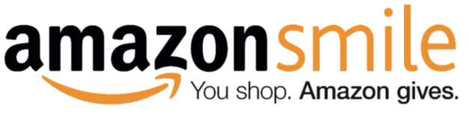
We all shop at Amazon,
so why not give back to
Simley Soccer when we shop!?

The Simley Soccer Booster Club is set up on the Amazon Smile program. 0.5% of eligible purchases go straight to our program!!
What do you have to do?
Log onto smile.amazon.com
Select Simley Soccer Booster Club
as the organization you are supporting.

Shop Amazon the way you would normally shop
and the soccer program gets the money.

Each time you shop on Amazon, login through smile.amazon.com
Each time you shop, you will see the menu bar below so you know
eligible purchases are going towards Simley Soccer!
