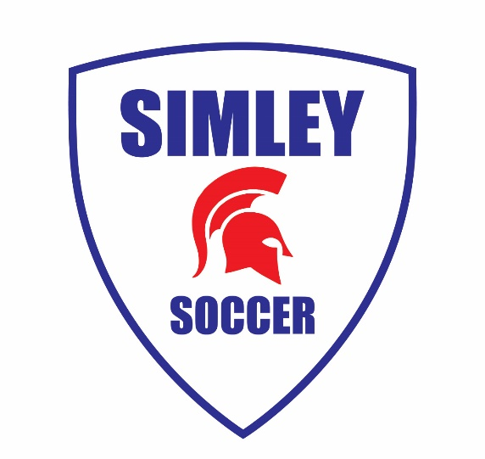

Simley Soccer Girls:

We hope everyone is staying safe and healthy during these uncertain times. We are excited to get the season started on August 17th! In order to keep everyone healthy and the risk of transmission low, we have decided to not hold any optional training sessions (formerly known as “captains’ practices”) during the week of August 10-14. This was a tough decision, but we would rather not risk anything that could prevent us from beginning our season on the 17th.

Although we won’t be getting together on the soccer field before the first preseason practice, we encourage all players to get out and get some touches on the ball as well as doing some cardio fitness. If you need suggestions on what to work on, feel free to contact one of us or any of the upperclassmen.

Remember, we have a player and parent meeting at Simley on Thursday, August 13th at 7:30pm. Please wear a mask to this meeting. There will be lots of important information announced, so please do your best to attend this.

See you soon!

Love, your 2020 Captains

Zoe Boughton (651.485.2823)
Kate Carlson (651.283.9750)
Ellah Larson (651.242.6662)

