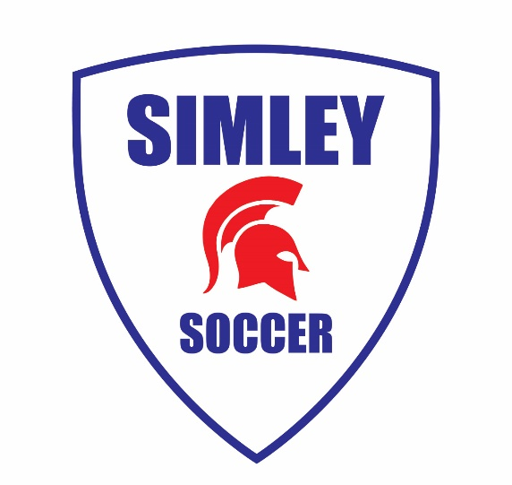

Welcome to the 2020 Soccer Season!
Attention 2020 Simley Boys Soccer Players:

Unfortunately, we have been cut short on our Captain’s Practice this year due to new rules by the Minnesota State High School League and COVID-19. We would like to thank everyone who was able to attend before we had to stop practices. We hope that everyone continues training individually leading up to the week of tryouts for this season.

On the chance we are lucky enough to resume training, we will notify everyone ASAP. If you have any questions regarding the upcoming soccer season, feel free to contact one of us at the numbers below.

We hope to see you all at tryouts, which begin on August 17th with Coach Keller!

See you soon!

Your 2020 Captains
Ryan Eckstrom (651.252.9663)
Ben Hatcher (651.238.5242)
Drew Jeffers (651.425.1335)

