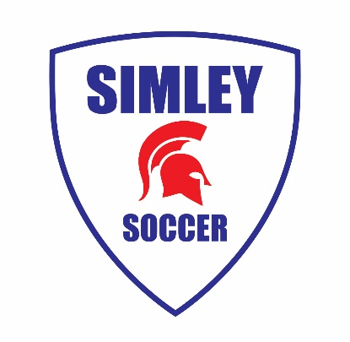
July 2020

Dear Simley High School Boys Soccer Players:

The high school soccer season will soon be upon us. Hopefully, you are enjoying your summer and working hard in preparation for the beginning of the 2020 soccer season. Below are some important dates to get on your calendar.

Tryouts begin on Monday, August 17 and run through Friday, August 21. Please wear a white or plain-colored T-shirt with no team or club logos on them during tryouts. Please also arrive 25 minutes early for check in:

- Monday, Aug. 17: 9:00 am-11:00 am; 3:00 pm-4:30 pm
- Tuesday, Aug. 18: 9:00 am-11:00 am; 3:00 pm-4:30 pm
- Wednesday, Aug. 19: 9:00 am-11:00 am; 3:00 pm-4:30 pm
- Thursday, Aug. 20: 9:00 am-11:00 am; 3:00 pm-4:30 pm
- Friday, Aug. 21: 9:00 am-11:00 am; 3:00 pm-4:30 pm
- Saturday, Aug.22: TBD

Please bring all the soccer essentials to every tryout and training session:
- Soccer ball (size 5) (inflated properly)
- Water
- Shin guards
- Soccer cleats
- Running shoes
- Correct clothing for the weather

On Thursday, August 13 at 6 PM, there will be a players and parents meeting at the Simley High School auditorium. The coaches will meet with the players and parents. We will go over what this upcoming season will look like, so we strongly encourage you to attend to hear all the updates as it will be a bit different this year. We will plan on social distancing at this event and everyone will be required to wear a mask.

To best communicate with players and parents, we need your contact information. Please use this link to provide your information: tinyurl.com/yc9pa2ca. You can also sign up for my text messages by downloading the “Remind” app. Instructions to sign up for this app can be found on the Simley Soccer website.

I am looking forward to an exciting and challenging season ahead. Please come to tryouts focused, on time, hydrated, and ready to compete, meaning you're in shape condition-wise and comfortable with a soccer ball at your feet.

In the meantime, if you have any questions or concerns regarding the Simley High School Boys Soccer Program, do not hesitate to contact me.

Best regards,

Anthonyr Keller, Simley High School Varsity Boys Soccer Coach
Email: anthonykeller9@gmail.com | Mobile: 612.616.8593

